# The Government Revenue and Development Estimations (the GRADE) User Guide

# Table of Contents

Introduction……………………………………………………………………………………………………...2

The background of the GRADE project………………………………………………………………………..2

Why use government revenue per capita ……………………………………………………………………3

The importance of understanding the relationship between government revenue and outcomes…..3

The modelling……………………………………………………………………………………………………4

The data used……………………………………………………………………………………………………5

Frequently Asked Questions about the GRADE

*What does the GRADE show?..................................................................................................................................6*

*Do all countries benefit the same when there is an increase in revenue?................................................................6*

*Does the GRADE assume governments spend additional revenue on specific sectors?.........................................6*

*After an increase in revenue, when do benefits accrue?..........................................................................................6*

*Why do all countries not benefit the same when there is an increase in government revenue?..............................6*

*Which currency does the GRADE use?....................................................................................................................7*

*Who did the research?..............................................................................................................................................7*

*Who created the visualisations?...............................................................................................................................7*

*Who funded the research underpinning the GRADE?..............................................................................................7*

Using GRADE-DOH/rights - step by step guide and frequently asked questions…………………………8

Using GRADE- Mortality - step by step guide and frequently asked questions…………………………..9

Appendix A Definitions for the determinants of health used in the GRADE………………………….....10

# Introduction

The GRADE (Government Revenue and Development estimations) allows the user to predict what would happen regarding access to health (DOH) determinants and survival if government revenue increases in an individual country. The research underpinning the GRADE used data from most countries globally, over several decades, to model this relationship. This model may assist advocates in assessing policies and multinational corporations to review their economic, social and governance contributions (ESG) acting via their contributions to public finances in a given country.

This guide aims to assist the user to understand the thinking behind the GRADE, the modelling, the sources of data, frequently asked questions and how to use the GRADE. More detailed information on the modelling is available in the associated publications, and there are short recordings on the website explaining how to use it.

 We believe this work and its visualisation will offer robust and realistic estimates of the potential of increased government revenue and will be of interest to organisations who advocate for a reduction in debt service and tax avoidance. It may also be of interest to corporations for their economic, social and governance reporting.

# The background of the GRADE project

The GRADE project aims to contribute to everyone having access to their DOH, which are also Sustainable Development Goals (SDGs) 3,4,6 and fundamental economic and social rights by 2030. The GRADE was developed to assess the impact of an increase or decrease in government revenue on these developmental outcomes.

This project will allow estimation of the downstream impacts of upstream decisions. Some decisions impact government revenue, and we model the impact of government revenue per capita on access to health determinants. Therefore, if a policy change increases or decreases government revenue, the user can estimate the effect on access to health determinants. These models may assist with attribution of responsibility and hopefully, remedy. This work has helped advocacy groups target their efforts towards the policies most likely to increase government revenue, government spending on public services, access to health determinants, and improved health outcomes.

The GRADE was developed by a multi-disciplinary team; Dr Bernadette O'Hare, senior lecturer in Global Health and Professor Stephen Hall at the School of Business, the University of Leicester, who carried out the modelling. Dr Stuart Murray, St Andrews used the models and underpinning data to produce the online visualisation. Colleagues who contributed to GRADE-Mortality include [Janine Illian](javascript:;), [Innocent Makuta](javascript:;), [Kyle McNabb](javascript:;), [Andre Python](javascript:;), [Syed Haider Ali Zaidi](javascript:;) & [Naor Bar-Zeev](javascript:;), from the following institutions, the School of Mathematics and Statistics, the University of Glasgow,  the Department of Economics, Chancellor College, the University of Malawi, the Overseas Development Institute, London, UK, the Division of Education, the Oxford Big Data Institute, Li Ka Shing Centre for Health Information and Discovery, the University of Oxford, UK the Center for Data Science, Zhejiang University, Zhejiang Province, P. R. China, the Bloomberg School of Public Health, International Vaccine Access Center, Department of International Health, Johns Hopkins Bloomberg School of Public Health, MD, Baltimore, Maryland, USA.

Dr O'Hare worked as a paediatrician in sub-Saharan Africa for ten years, where large numbers of children die from easily avoidable diseases. The team believes increased government spending on the determinants of health could offer sustainable solutions and hence their interest in the leaks from government revenues or lost government revenues. If leaks from government revenues are reduced, government spending will increase as will coverage of health determinants, reducing mortality. Research shows that the significant leaks from government revenue baskets include tax abuses and debt service and low government revenue increases corruption which further drives lost government revenues.

# Why use government revenue per capita?

The GRADE uses government revenue per capita rather than say, health spending, for two reasons.

1. A better understanding of the relationship between government revenue per capita and the determinants of health and mortality/survival is useful because the policies and practices of governments, multinational organisations, including corporations and banks, are much more likely to influence GR, than government spending. For example, the facilitation of capital flight results in a large public debt or tax avoidance by multinational corporations. In contrast, international actors, except for the international monetary fund and donors in highly aid-dependent countries, are unlikely to influence government spending (B. A.-M. O'Hare et al., 2018). An appreciation of the scale could contribute to policymaking, advocacy, and economic and social governance decisions by multinational corporations and banks.
2. Government revenue per capita also reflects the ability of governments to spend across all sectors. Many studies have concentrated on just one part of social spending, for example, spending on health. We know that sectors outside the health sector account for half of the reduction in child mortality in low- and middle-income countries. For example, spending on education raises maternal literacy, which is known to reduce child mortality 2,3. Also, government spending on health is a fraction (<10%) of total government spending in low-income countries. In contrast,

# The importance of understanding the relationship between government revenue and outcomes

When governments have more revenue, studies have shown that more is spent on public services, such as schools and hospitals and reduce mortality 4. Government revenues will increase If leaks are curtailed, see figure1.

**Figure 1 Framework for the GRADE**

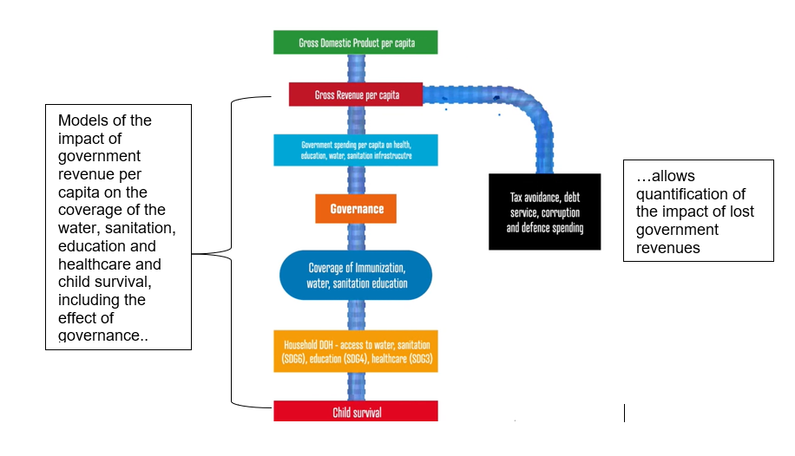

**The DOH are Sustainable Development Goals (SDGs), 2,4,5, and 6 and fundamental economic and social rights.**

For every life saved, many thousands more have improved life chances by attending school, drinking clean water, and accessing healthcare, see figure 2.

**Figure 2 Higher coverage of the determinants of health results in increased survival**

# The modelling

**There are currently two visualisations available on the GRADE website**

1. **GRADE- DOH/Rights –** (underpinning research forthcoming)
2. **GRADE Mortality based on** [Government Revenue and Child and Maternal Mortality.](https://link.springer.com/article/10.1007/s11079-020-09597-0)
3. **GRADE- DOH/Rights**

The GRADE project provides a model of the relationship between government revenue per capita and six determinants of health (DOH), and child and maternal survival, while controlling for each quality of governance (QoG). For GRADE- DOH, we did not add any controls to the model because we want to capture the total effect of government revenue per capita and QoG. Most variables used in the literature are influenced by government revenue and QoG, so there would be collinearity problems. The actual and fitted models are available.

The DOH currently modelled includes basic water facilities, safe water facilities, basic sanitation, safe sanitation, schooling and the immunisation rates. See the section on data for the definitions. We plan to model fertility, skilled births attendance, adolescent pregnancy, neonatal mortality, universal health coverage and gender-disaggregated education in the next version.

We employed an unbalanced non-linear panel data study for 217 countries between 1960-2000 and expressed health determinants as a percentage ranging from 0 to 100. A linear relationship between revenue and these variables would not be appropriate, as this would not respect these boundaries. We employed a logistic function as the correct specification to model such variables. A standard panel logistic function would impose the same shape 'S' curve on all countries, which is not appropriate. Therefore, we augmented the logistic function parameters with measures of governance quality, which allows each country to have a different 'S' shape as its government's quality varies.

We found that increased government revenue is associated with an increase in the coverage of health determinants. The quality of governance significantly amplifies the size of this influence in each country.

1. **GRADE Mortality**

GRADE-mortality visualises the relationship between government revenue and child and maternal mortality based on modelling, which used a two-way fixed-effects specification. We controlled for independent variables including demography, education, geography, and specific health challenges. Data for the dependent and independent variables were taken from the World Development Indicators from 1980 to 2016 for 191 countries (The World Bank. [2018](https://link.springer.com/article/10.1007/s11079-020-09597-0#ref-CR42)).

# The data used

**Government Revenue per capita data**

For the GRADE-DOH modelling, the Government revenue per capita data used was from the World Development Indicators, https://databank.worldbank.org/WDI, downloaded 12/8/2020. Government revenue per capita is calculated by multiplying the revenue, excluding grants (% of GDP) *GDP per capita (constant 2010 US$). Our reasoning for using the World Development Indicators (WDI) government revenue data for the modelling was data availability before 1980. We could also extract government revenue per capita data, data on governance, mortality, and the determinants of health from one source.

For the visualisation, there were 60 countries with no data available for any of the years (1960-2020) in the WDI, and we used Government Revenue data from the UNU WIDER Government Revenue Dataset (GRD), which was last updated June 2020 with data for 2018. The GRD has data available for 196 countries for the years 1980-2018 5. (See the spreadsheet BASE Population, column L on the GRADE-DOH tab).

The UNU WIDER GRD dataset has general and central government revenue, and we used the former as the latter would underestimate total revenue in fiscally decentralised states. Data which includes and excludes grants are available, and we used total general government revenue, excluding grants as this variable best reflects the capacity of domestic revenue. For the same reason, we used data which includes social contributions. The GRD expresses all data as a percentage of GDP taken from the World Economic Outlook (WEO), in Local Currency Units (ICTD/UNU-WIDER 2018b). GR as % of GDP was multiplied by the GDPpc in constant 2010 US$ (taken from the World Development Indicators), to convert to government revenue per capita. There is missing data for government revenue per capita, but we used linear interpolation with two known data points, we did not extrapolate any data.

Water, sanitation, and immunisation are recorded as a percentage ranging from 0 to 100. The education data used is the school life expectancy (SLE), both primary and secondary for both sexes and is the number of years of education a child of school entrance age can expect to receive. The maximum SLE is just under 17 years, and we express the data as a percentage of 17, which gives us a variable between 0 and 100. See Appendix A for the definitions of the variables used.

For the GRADE – Mortality modelling we used the Government Revenue data from the UNU WIDER Government Revenue Dataset (GRD). At the time of this modelling there was data for 191 countries (the most recent version has data for 196 countries).

# Frequently Asked Questions about the GRADE

## What does the GRADE show?

Using panel data, the relationship between government revenue per capita and mortality rates and the determinants of health was highly non-linear, and countries with small per-capita government revenues have a better scope for reducing mortality rates. However, as per capita revenue rises, the possible gains decline rapidly.

## Do all countries benefit the same when there is an increase in revenue?

No. A given amount of additional revenue does not increase health determinants or reduce the mortality rates in different countries by the same amount. There is considerable scope for reducing mortality rates and saving lives in countries with small per-capita revenues.

The reasons for this are as follows -

1. The average government revenue per person in wealthy, or high-income countries, is more than a hundred times larger than in low-income countries, countries. So, additional income in a low-income country is relatively larger.
2. The interventions required to reduce mortality rates when rates are very high are usually low-cost, such as access to clean water, sanitation, education and primary healthcare. On the other hand, reducing mortality rates when they are moderately high, involves the provision of advanced healthcare.

## Does the GRADE assume governments spend additional revenue on specific sectors?

No. All governments allocate their resources according to their national priorities. The GRADE assumes that governments will spend any additional revenue in the same way they have been in recent years.

The benefits in terms of health and therefore, reductions in mortality are likely to result from increased spending across multiple sectors, with increased access to education, water, sanitation and healthcare.

## After an increase in revenue, when do benefits accrue?

Increased spending takes time to show an impact, but most of the benefit has accrued within 5-6 years. The GRADE does not attempt to estimate the benefits during the first five years.

## Why do all countries not benefit the same when there is an increase in government revenue?

1. In 2016, the average government revenue per person was $80 in low-income countries, $380 in lower-middle-income countries, $1250 in upper-middle-income countries and $12,750 in high-income countries. For example, an additional 200 million in revenue in a low-income country with a population of 10 million will increase government revenue per capita by $20, which is an increase of 25%. In comparison, in a high-income country, the increase will be a 0.16% increase on average. Thus, extra revenue will go much further in terms of access to services that contribute to health and ultimately saves lives.
2. Gains are smaller at higher levels of development. The reason for this is reducing high child mortality rates, for example from 150 to 75 per 1000 live births involves reducing more easily preventable deaths by, for example, ensuring more people have access to clean water, sanitation and primary healthcare. On the other hand, reducing child mortality rates from 40 to 20 per 1000 live births involves reducing less preventable deaths, requiring more advanced healthcare services.

## Which currency does the GRADE use?

The modelling used constant 2010 USD, so ideally if inputting additional revenue, convert this to 2010 values, see <https://fred.stlouisfed.org/series/GDP/> deflate from other years to 2010 values.

## Where can I obtain the data used for the models?

At the bottom of the visualisation there is a button to download the data, see figure 3 and 4.

## Who funded the research underpinning the GRADE?

The GRADE project is supported by the Scottish Funding Council, the Global Challenges Research Fund and the Professor Sonia Buist Global Child Health Research Fund.

## Using GRADE-DOH/rights - step by step guide and frequently asked questions

**Figure 3 Select the GRADE-DOH/rights tab**

**1.Select country,** hover over the country, and click in the map or select from the dropdown.

The map can be moved and zoomed

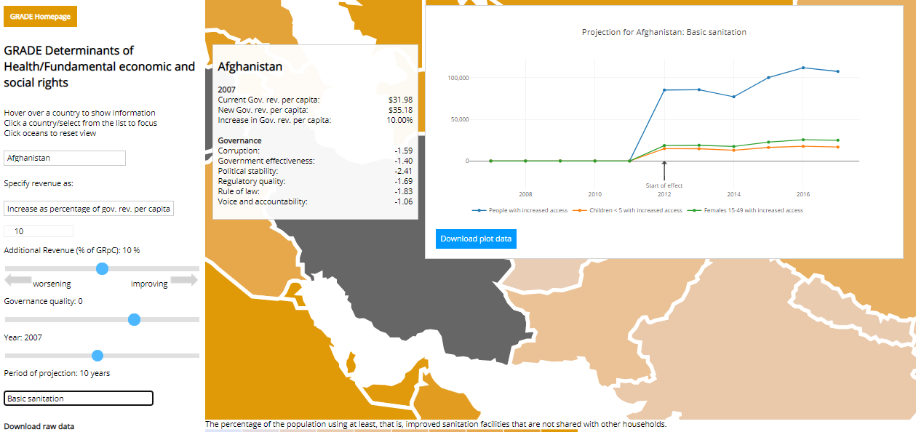

**6. Get the data**

**2. Input the additional revenue – ideally as the increase as a percentage of government revenue**

**3. Select the year of increase, but remember most losses occur over many years, and it takes about five years before benefits accrue.**

**5. Select the determinant of health or increase in survival (either children or mothers). For water and sanitation use the average of the period of projection as these may vary (see FAQ below). For extra child school years and deaths averted use the total for the period.**

**4. Select the period of projection. The longer the better, but you may have to toggle the start year and the period of projection depending on data availability**

**Frequently asked questions on GRADE – DOH / Rights**

**Why do GRADE-DOH/Rights use additional revenue as a percentage of government revenue?**

The reason is that we often have estimates on lost government revenues for one year, but of course, most losses occur over many years, for example, tax abuses or debt services. However, the value of currencies changes with time. Rather than deflating the additional revenue for each year, we recommend calculating the extra revenue as a percentage of government revenue and using this for all years.

**Why do the estimates fluctuate?**

The model incorporates the quality of governance, which has a considerable influence on the impact of an increase in government revenue. This varies between years, so, the estimates vary between years.

**Why do we use the average over the period for water and sanitation but the total for school years and lives saved?**

Some variables, such as water and sanitation, are stock variables; this means that an increase in government revenue produces a one-off increase in the stock of these capital assets. Because there are slight differences over time in the effect, caused by changes in governance or government revenue, we present the average change over the projection period selected. Other variables are flow variables, such as lives saved and additional school years. In this case, an increase in government revenues represents the lives saved and extra school years, every year over the projection period. Therefore, we present the sum of the annual increase over the projection period as the total effect.

## Using GRADE- Mortality - step by step guide and frequently asked questions

**1.Select country,** hover over the country, and click in the map or select from the dropdown. The map can be moved and zoomed

**Figure 4 Select the GRADE-Mortality tab**

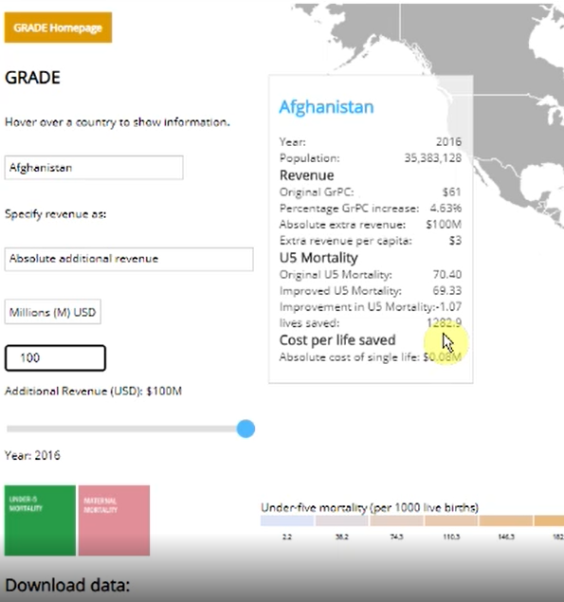

**2. Input the additional revenue for example it is known that tax abuse in the selected country was $100 million. See FAQ on which currency.**

**5. Get the data**

**4. Select either under five mortality or the maternal mortality ratio.**

**3. Select the year, but remember most losses occur over many years, the GRADE -mortality provides a snapshot. To see the effect over several years, see GRADE - DOH.**

**Frequently asked questions on GRADE - Mortality**

**What does it mean if the country appears black for a given year?**

This means there is not enough data to provide estimations for this country this year. The missing data may be one of the model variables, including government revenue per capita. See if there is data for some of the years either side to the year of interest.

**What do lives saved mean?**

Suppose there was an increase in government revenue. In that case, this is the number of deaths that we project would be averted, remembering that it takes about five years to benefit from an increase in revenue to accrue and recognising that most losses from government revenues occur every year, year in and year out.

**How can I estimate the longer-term impact?** Use the GRADE – DOH/rights tool.

**GRADE – Mortality shows one year, why is this?**

Most losses occur over many years; the GRADE -mortality provides a snapshot and remember these gains take about five years to accrue. To see the effect over several years, use the GRADE -DOH.

Appendix A Definitions for the determinants of health used in GRADE6

Definitions from the World Bank

**Basic drinking water services** – the percentage of the population drinking water from an improved source, provided collection time is not more than 30 minutes for a round trip. Improved water sources include piped water, boreholes or tube wells, protected dug wells, protected springs, and packaged or delivered water.   
**Safely managed drinking water services** – the percentage of the population using drinking water from an improved source accessible on-premises, available when needed and free from faecal and priority chemical contamination.   
**Basic sanitation services** - the population using at least, that is, improved sanitation facilities not shared with other households. This indicator encompasses both people using basic sanitation services as well as those using safely managed sanitation services. Improved sanitation facilities include flush/pour flush to piped sewer systems, septic tanks or pit latrines; ventilated improved pit latrines, compositing toilets or pit latrines with slabs.  
**Safely managed sanitation services** –the population using improved sanitation facilities, not shared with other households and where excreta are safely disposed of in situ or transported and treated offsite. Improved sanitation facilities include flush/pour flush to piped sewer systems, septic tanks or pit latrines: ventilated improved pit latrines, compositing toilets or pit latrines with slabs.  
**Child immunisation** - the percentage of children ages 12-23 months who received diphtheria, pertussis (or whooping cough), and tetanus (DPT) vaccinations before 12 months or at any time before the survey. A child is adequately immunised against (DPT) after receiving three doses of vaccine.  
**School life expectancy** (primary and secondary), both sexes (years) -the number of years a person of school entrance age can expect to spend within the specified education level. For a child of a certain age, the school life expectancy is calculated as the sum of the age-specific enrolment rates for the levels of education specified. The part of the enrolment not distributed by age is divided by the school-age population for the level of education they are enrolled in, multiplied by the duration of that level of education. The result is added to the sum of the age-specific enrolment rates. A relatively high school life expectancy indicates a greater probability for children to spend more years in education and higher overall retention within the education system. Note that the expected number of years does not necessarily coincide with the expected number of education grades completed because of repetition. Since school life expectancy is an average based on participation in different levels of education, the expected number of years of schooling may be pulled down by the magnitude of children who never go to school.

**The Worldwide Governance Indicators**

The WGI reports aggregate and individual governance indicators for over 200 countries and territories over 1996–2019 for six dimensions of governance (see table 1. These are composite indicators, based on more than thirty data sources. Firstly, individual questions from the underlying sources are assigned to one of the aggregate indicators. The compilers then rescale the data to make it comparable across sources using the unobserved components model. The resulting composite measures are in units of a standard normal distribution with mean zero, running from -2.5 to +2.5 and higher values corresponding to better governance 7,8.

**Table 1: Definitions of dimensions of Quality of Governance Worldwide Governance Indicators**

|  |  |
| --- | --- |
| Dimension of Governance | What it captures |
| Control of corruption | Perceptions of the extent to which public power is exercised for private gain, including both petty and grand forms of corruption, as well as "capture" of the state by elites and private interests |
| Government effectiveness | Perceptions of the quality of public services, the quality of the civil service and the degree of its independence from political pressures, the quality of policy formulation and implementation, and the credibility of the government's commitment to such policies |
| Political stability | Perceptions of the likelihood that the government will be destabilised or overthrown by unconstitutional or violent means, including politically-motivated violence and terrorism |
| Regulatory quality | Perceptions of the ability of the government to formulate and implement sound policies and regulations that permit and promote private sector development |
| The rule of law | Perceptions of the extent to which agents have confidence in and abide by the rules of society, and in particular the quality of contract enforcement, property rights, the police, and the courts, as well as the likelihood of crime and violence |
| Voice and accountability | Perceptions of the extent to which a country's citizens are able to participate in selecting their government, as well as freedom of expression, freedom of association, and a free media |

1 O’Hare BA-M, Mfutso Bengo E, Devakumar D, Mfutso Bengo J. Survival rights for children: What are the national and global barriers? AFRICAN HUMAN RIGHTS LAW JOURNAL. *African Hum Rights Law J* 2018; **18**: 508–26.

2 Gakidou E, Cowling K, Lozano R, Murray CJL. Increased educational attainment and its effect on child mortality in 175 countries between 1970 and 2009: A systematic analysis. *Lancet* 2010; **376**: 959–74.

3 Bishai DM, Cohen R, Alfonso YN, Adam T, Kuruvilla S, Schweitzer J. Factors contributing to maternal and child mortality reductions in 146 low - and middle - income countries between 1990 and 2010. *PLoS One* 2016; **11**: e0144908.

4 Reeves A, Gourtsoyannis Y, Basu S, McCoy D, McKee M, Stuckler D. Financing universal health coverage— Effects of alternative tax structures on public health systems: Cross-national modelling in 89 low-income and middle-income countries. *Lancet* 2015; **386**: 274–80.

5 Prichard W, Cobham A, Goodall A. The ICTD Government Revenue Dataset. 2014 https://www.wider.unu.edu/sites/default/files/Data/ICTD_GRD_User_Guide.pdf.

6 The World Bank. Databank - The World Bank. 2020. https://data.worldbank.org/ (accessed Dec 10, 2020).

7 Kaufmann D, Kraay A, Mastruzzi M. The Worldwide Governance Indicators Methodology and Analytical Issues. *Dev Res Group, World Bank* 2010.

8 Kaufmann D, Aart Kraay. Worldwide Governance Indicators. 2020. https://info.worldbank.org/governance/wgi/ (accessed Nov 20, 2020).